

**Community Traffic Survey**

**What is the survey about?**

The aim of this survey is to get an understanding of how transport linkages impact upon community members and businesses in the Wheatbelt.

**Why should I fill in this survey?**

This is your chance to have your say. We think this is a very valuable piece of work as it will help to identify traffic and road related issues in the region.

**Will my answers be confidential?**

Your answers are important to us and will be kept confidential. The only personal information we seek is the community you are from, so we can isolate where the issues you outline are occurring. You will not be asked to provide your name or any other information that may identify you. Individual responses will be kept strictly confidential and no names will be identified in any reports or communications.

**How will the results be used?**

Survey responses will be complied in to a report and presented to the RDA Wheatbelt Committee. This information will be used to identify opportunities to improve the service and support they offer to the region.

**Thank you for your participation in this project**

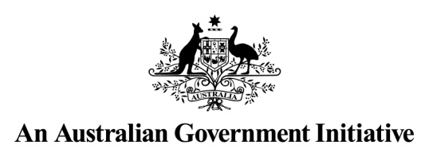



1. Which Shire do you live in, and are you on a rural property or in town?

............................................................................................................................................................

............................................................................................................................................................

1. On a scale of 1-5 (with 1 being worst and 5 being best), how would you rate the condition of the roads in your district?

1. Do you think the condition of these roads have improved, remained the same or gotten worse over the last 12 months?

1. What do you feel the primary reason for this is?

1. In terms of traffic flow do you feel it is lighter, remained the same or gotten heavier over the last 12 months?

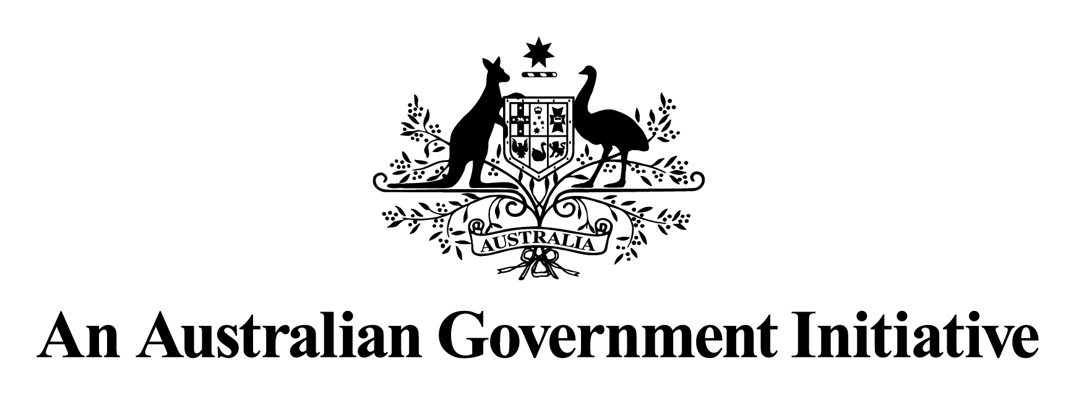

1. If you noticed a change in traffic flow, which type of vehicles did you find were more/less frequently on the roads?

**Community Traffic Survey**



**Community Traffic Survey**

1. Do you feel traffic noise heard from your home has increased, remained the same or decreased over the last 12 months?

1. Do you feel that the traffic flow to built up and residential areas has increased, remained the same, or decreased over the last 12 months?

1. Do you feel the general safety of the roads in your community has increased, decreased or remained the same in the last 12 months?

1. Do you have rail connections to your community (for freight or passenger services)?

Referring to your answer, how do you feel this benefits or is detrimental to your community?

............................................................................................................................................................

............................................................................................................................................................

............................................................................................................................................................

............................................................................................................................................................

Please return your completed questionnaire to Ebony Cowan before the 30th June 2012 via email at [ebony.cowan@rdawheatbelt.com.au](mailto:ebony.cowan@rdawheatbelt.com.au) or by post to Box 324 Narembeen WA 6369

