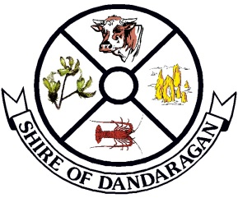
Shire of Dandaragan
NOTICE OF COUNCIL MEETINGS

Please be advised that the Ordinary Meeting of Council for 2018 / 2019 will be held on the following dates, times and venues:

DAY | DATE | TIME | MEETING VENUE
Thurs | 26 July 2018 | 4.00pm | Jurien Bay
Thurs | 23 August 2018 | 11.00am | Jurien Bay  School Visit
Thurs | 27 September 2018 | 4.00pm | Dandaragan
Thurs | 25 October 2019 | 4.00pm | Jurien Bay
Thurs | 22 November 2018 | 4.00pm | Cervantes
Thurs | 20 December 2018 | 4.00pm | Jurien Bay
Thurs | 24 January 2019 | 4.00pm  6.00pm | Badgingarra  AGM of Electors
Thurs | 28 February 2019 | 4.00pm | Jurien Bay
Thurs | 28 March 2019 | 4.00pm | Jurien Bay
Wed | 24 April 2019 | 4.00pm | Badgingarra
Thurs | 23 May 2019 | 4.00pm | Jurien Bay
Thurs | 27 June 2019 | 4.00pm | Jurien Bay

Public Forums commence immediately following the closure of the Council Meeting which is generally about 5.00pm.

Members of the public are most welcome to attend both the Council Meetings and the Public Forums.

BY ORDER OF THE COUNCIL

Scott Clayton
ACTING CHIEF EXECUTIVE OFFICER

