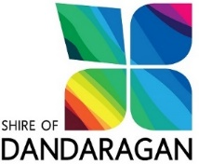

ACQUITTAL STATEMENT
Tronox Management and Shire of Dandaragan Sporting & Recreation Facilities Fund Program

ORGANISATION:
PROJECT TITLE:
FOR THE PERIOD: 2019 / 2020
REVENUE ITEMS
Shire of Dandaragan approved grant amount |  |  | (1)
Other Government Departments (please specify)
Other revenue received for project
Your organisation’s contribution

TOTAL REVENUE
EXPENDITURE ITEMS (ACTUAL)
(e.g. Administration costs, venue hire, instructor’s fees, equipment hire)
TOTAL ACTUAL EXPENDITURE |  | (2)
50% OF TOTAL ACTUAL EXPENDITURE  (not exceeding the original grant amount) |  | (3)

ORGANISATION CERTIFICATION
- I certify that the above figures are correct and that the organisation expended a total of $ __________(2) on the project as detailed in the grant application, including the Shire of Dandaragan grant of $________(3).
- I certify that I have the authority, as vested by the Board/Committee, to submit this acquittal documentation by electronic transmission.
- I have attached copies of all invoices/receipts from suppliers and an invoice from our organisation for release of grant funds to the total of $________ (3).
Name: ______________________ Signature: __________________________

Position Held: ________________________________ Date: ______________

