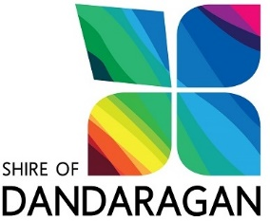

ACQUITTAL STATEMENT
Community Grants Program

ORGANISATION:
PROJECT TITLE:
FOR THE PERIOD: 2019-20
REVENUE ITEMS
Shire of Dandaragan grant amount |  |  | (1)
From other Government Departments (please specify)
Other revenue received for project
Your organisation’s contribution

TOTAL PLANNED REVENUE
EXPENDITURE ITEMS (ACTUAL)
(e.g. Administration costs, venue hire, instructor’s fees, equipment hire)
TOTAL ACTUAL EXPENDITURE |  | (2)
TOTAL UNSPENT GRANT MONEY |  | (3)

ORGANISATION CERTIFICATION
- I certify that the above figures are correct and that the ORGANISATION expended a total of $ (2) on the project as detailed in the Community Grant Application including the Shire of Dandaragan grant of $ (1).
- I certify that I have the authority, as vested by the Board/Committee, to submit this acquittal documentation by electronic transmission.
- I have provided copies of all invoices/receipts.
- I have contacted the Shire Manager Customer and Community Services regarding unspent grant funds to the total of $_______ (3) [take (2) from (1)]

Name: ______________________________ Signature:__________________________

Position Held: _______________________________ Date:_______________________

