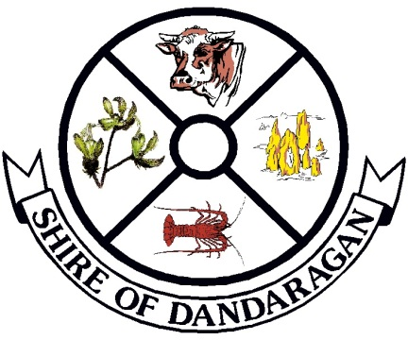

**NOTICE OF SPECIAL COUNCIL MEETING**

In accordance with Section 5.4 (a)(i) of the *Local Government Act 1995*, I advise that the Shire of Dandaragan will be holding a Special Council Meeting on the **Friday 7 May 2021** at **9.30am** at the **Council Chambers, Jurien Bay**.

The purpose of the meeting is to:

* Approve the sale of Lot 13 on Deposited Plan 173770, 3517 Dandaragan Road, Dandaragan



**Cr Leslee Holmes**

**PRESIDENT**

Shire of Dandaragan

PO Box 676

JURIEN BAY WA 6516

**30 April 2021**