Shire of Dandaragan

Disability Access and Inclusion Plan (DAIP) 2016 - 2020
This document is available in alternative formats, such as Braille, large print, digital (on disk or by email) upon request, and on the Shire’s website at http://www.dandaragan.wa.gov.au/

Table of Contents
Table of Contents Error! Bookmark not defined.
ACCESS AND INCLUSION POLICY STATEMENT 3
Policy Statement 3
1. BACKGROUND 5
1.1 The Shire of Dandaragan 5
1.2 Definition 5
1.3 People with disability in the Shire of Dandaragan 6
1.4 Labour Force Participation 7
1.5 Functions, Facilities and Services (both in house and contracted) provided by the Shire of Dandaragan 7
1.6 Legislative Framework 8
1.7 Initial Disability Service Plan 8
1.8 Previous Disability Access and Inclusion Plans 9
2 2016 – 2020 DISABILITY ACCESS AND INCLUSION PLAN 11
2.1 Development of the current version of the plan 11
2.2 Community consultation process 11
2.3 Findings of the consultation 11
2.4 Responsibility for implementing the DAIP 11
2.5 Communication of the plan 11
2.6 Review and evaluation mechanisms 12
2.6.1 Monitoring and Reviewing 12
2.6.2 Evaluation 12
2.7 Reporting of the DAIP 12
3 STRATEGIES TO IMPROVE ACCESS AND INCLUSION 13
4 IMPLEMENTATION PLAN 13
Outcome 1: ACCESS TO SERVICES 14
Outcome 2: BUILT INFRASTRUCTURE 15
Outcome 3: COMMUNICATIONS 17
Outcome 4: QUALITY OF SERVICE 18
Outcome 5: COMMENTS 18
Outcome 6: CONSULTATION 19
Outcome 7: EMPLOYMENT 20
Appendix 21

ACCESS AND INCLUSION POLICY STATEMENT

Objective
The Shire of Dandaragan is committed to ensuring that the community is an accessible community for people with disability, their families and carers.

The Shire of Dandaragan believes that people with disability, their families and carers who live in country areas should be supported to remain in the community of their choice.

The Shire of Dandaragan is committed to consulting with people with disability, their families and carers and where required disability organisations to ensure that barriers to access are addressed appropriately.

Policy Statement
The Shire of Dandaragan will ensure its agents and contractors work towards achieving the seven desired outcomes of its Disability Access and Inclusion Plan, which are:

Outcome 1: People with disability have the same opportunities as other people to access the services of, and any events organised by the Shire of Dandaragan.
  - Ensure that events, provided or funded, are accessible to people with disability;
  - Make library technology as accessible as possible;
  - Monitor Shire services to ensure appropriate access and inclusion;
  - Ensure that people with disability are provided with an opportunity to comment on access to services.

Outcome 2: People with disability have the same opportunities as other people to access the buildings and other facilities of the Shire of Dandaragan.
  - Ensure that all new or redevelopment works provide access for people with disability;
  - Ensure the ACROD parking meets the requirements of people with disability in terms of quantity and location;
  - Ensure that all building and facilities meet the standards for access and other needs;

  - Ensure that disabled facilities and services are clearly indicated and accessible; and
  - Ensure that recreational areas are accessible.

Outcome 3: People with disability receive information from the Shire of Dandaragan in a format that will enable them to access the information as readily as other people are able to access it.
  - Ensure that the community is aware that information is available in alternative formats; and
  - Improve employee awareness of information available in alternative formats.

Outcome 4: People with disability receive the same level and quality of service from the employees of the Shire of Dandaragan as other people receive from the employees of the Shire of Dandaragan.
  - Ensure that Council Members and employees are aware of access needs and can provide appropriate services; and
  - Improve the awareness of new Council Members and employees about disability and access issues.

Outcome 5: People with disability have the same opportunities as other people to make complaints to the Shire of Dandaragan.
  - Ensure that grievance mechanisms are accessible for people with disability and are acted upon.

Outcome 6: People with disability have the same opportunities as other people to participate in any public consultation by the Shire of Dandaragan.
  - Ensure that people with disability are consulted about the Disability Access and Inclusion Plan and other significant planning processes; and
  - Ensure that people with disability are aware of and can access other established consultation processes.

Outcome 7: People with disability have the same opportunities as other people to obtain and maintain employment with the Shire of Dandaragan.

BACKGROUND

1.1 The Shire of Dandaragan
The Shire of Dandaragan is located in the Central West of Western Australia, 168km north of Perth. The Shire covers 6934km² and encompasses the towns of Jurien Bay, Cervantes, Badgingarra, Dandaragan and Regans Ford.

The Shire has a diverse range of local industries. These include grain and pastoral farming, rock lobster fishing and processing, mining, tourism, viticulture, aquaculture, horticulture and floriculture.

The Shire has an estimated population of 3186, which increases significantly during the peak tourist season. The opening of Indian Ocean Drive in 2010 resulted in a much higher visitor population to the region.

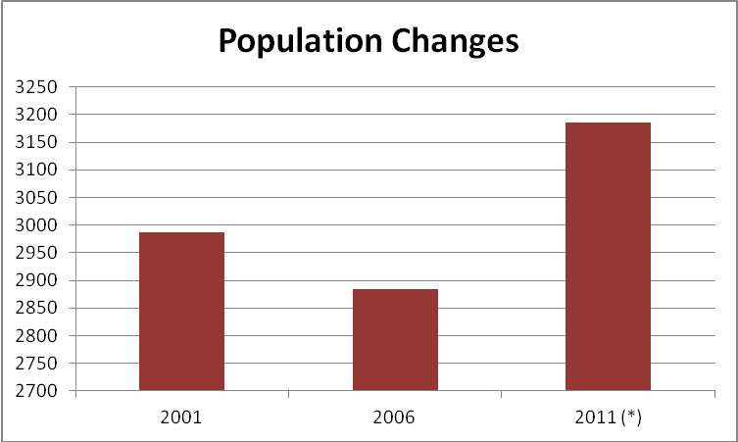
- Unconfirmed 2011 census data

It is expected that the population of the Shire will increase on average by 2.2% annually over the next 20 years to become the regional centre for a large population.

1.2 Definition
The Disability, Ageing and Carers, Australia: Summary of Findings, 2003 (Disability Services Commission) defined disability as “any limitation, restriction impairment, which has lasted, or is likely to last, for at least six months and restricts everyday activities.” Disability can be physical, intellectual, sensory or psychological.

People with Disability in the Shire of Dandaragan
In the 2011 Census 3% of the Shire’s population stated that they were in need of assistance, whilst the 2009 Australia wide survey of Disability, Ageing and Carers indicated that 18.5% of Australians reported having a disability. This suggests that approximately 100 people within the Shire of Dandaragan are living with a disability, but that number could be higher. When considering the additional visitors that stay in Shire of Dandaragan the impact of having accessible facilities and services is a significant factor in the planning and development of Shire assets.

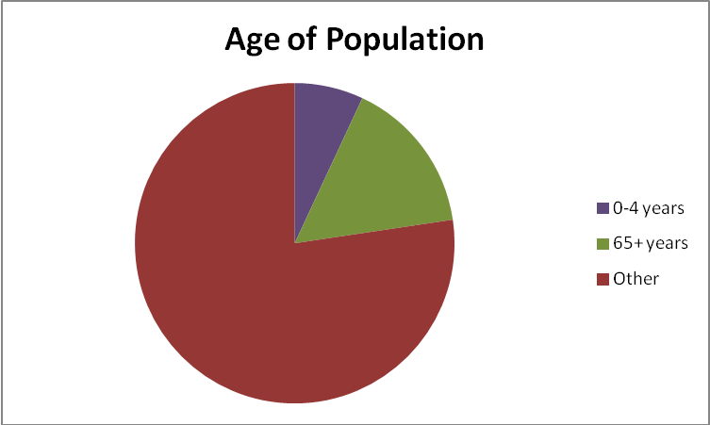

The 2011 census revealed that 17% of the Shire’s population was over 65 years of age. This represents an increase of 1% from the 2006 census and a 5% increase from the 2001 census.

1.4 Labour Force Participation
In 2012, there were 2.2 million (14.4%) Australians aged 15-64 years, of 'prime working age', with disability. Nearly half (47.3%) of all working-age people with disability were not in the labour force. One-third (33.6%) of these people were permanently unable to work, while one-fifth (19.3% or 201,500) had no employment restriction, reporting that it was not their disability which was preventing them from working.

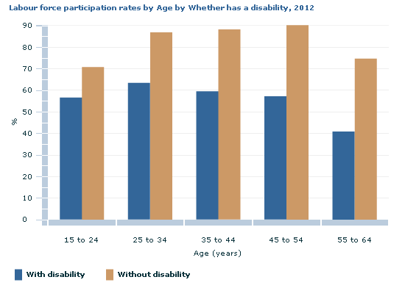

1.5 Functions, Facilities and Services (both in house and contracted) provided by the Shire of Dandaragan

The Shire of Dandaragan is responsible for a range of functions, facilities and services comprising:
- Service to Property including: Construction and maintenance of roads, footpaths and cycle facilities; land drainage; waste collection and disposal; litter control and street cleaning; planting and caring for trees, numbering of buildings and lots, street lighting; and bush fire control.
- Services to the Community consisting of: Provision and maintenance of playing areas and reserves; management of recreation centres; library and information services, environmental health services; transmission of radio and TV; senior citizen centre and meals on wheels service; and health education.
- Regulatory Services involving: Planning of roads and subdivisions in accordance with the town planning scheme; building approval for construction, additions and alterations; environmental health; and ranger services, including enforcement of local laws, dog control and the development, maintenance and control of parking facilities.
- General Administration: The provision of general information to the public and the lodging of complaints and payment of rates.
- Processes of Government: Ordinary and special Council and committee meetings; electors meetings and election of Council members.

1.6 Legislative Framework
The Western Australian Disability Services Act requires all Local Governments to develop and implement a Disability Access and Inclusion Plan (DAIP) to ensure that people with disability have equal access to facilities and services.

Other legislation underpinning access and inclusion includes the Western Australia Equal Opportunity Act (1984) and the Commonwealth Disability Discrimination Act 1992 (DDA), both of which make discrimination on the basis of a person’s disability unlawful.

1.7 Initial Disability Service Plan
The Shire of Dandaragan is committed to facilitating the inclusion of people with disability through the improvement of access to its information, facilities and services. Towards this goal, the Shire adopted its first Disability Service Plan (DSP) in 1996 to address the access barriers within the community.

Since the adoption of the initial DSP, the Shire has implemented many initiatives and made significant progress towards better access.

1.8 Previous Disability Access and Inclusion Plans
Following the 1996 plan the Shire of Dandaragan adopted the 2007 -2011 Disability Access and Inclusion Plan which provided the framework to improve access and inclusion for all of the Shire’s residents and visitors. The plan was developed using six agreed outcomes and outlined specific strategies to be achieved during the plans life. All of the strategies were achieved and reports generated annually to reflect the achievements throughout the year.

At the completion of the 2007 – 2011 Disability Access and Inclusion Plan the Shire of Dandaragan embarked on the new phase of access and inclusion and commenced development of the 2012 – 2017 Plan that provided the strategies for a further five years. Some of the achievements included:

Events that are supported by Shire of Dandaragan are carried out in venues with unrestricted access.
Books in library are available in large print, audio books available and books in Braille can be ordered on request.
Feedback mechanism developed
Ongoing assessment of accessibility with building approval process
All ACROD bays were assessed and an upgrade plan developed. An ACROD bay was constructed on Aragon Street, Cervantes.
Audited and identified access barriers to buildings and facilities using the access Resource Kit and AS 1428.1
Hearing augmentation loop installed in Council Chambers.
Assessed and made changes to all but one entrance door of Community Centres across the Shire
New footpaths have been constructed following the footpath program.
Asphalt and concrete paths installed at Catalonia Street foreshore park in Cervantes.
Upgrade of public toilets including improved disabled access including the Cook Street and Federation Memorial Park.
All public documents have notation indicating the document is available in larger print or alternative format.
All new employees are given a copy of the DAIP in their induction package upon commencing employment. All staff producing Council documents has been made aware of notation requirements.
Ongoing training is provided to educate staff and Council Members as required.
A range of mediums are used to consult with people with disabilities including newspaper articles, advertising, internet, and public meetings in accessible locations.
All documents that require community consultation have notice indicating that they can be obtained in larger print on request.
A wide range of documents are available on the website and the number is continuously being expanded.
In 2015 the Shire commissioned a consultant to convert the Shire of Dandaragan History Book (Plateau, Plain and Coast) into an audio book. This is available in libraries. It is planned to upload this version to the Shire’s website.
Improved cycle/footpath network including the ‘Beachridge’ subdivision access along Bashford Street.
Upgraded path network in the vicinity of the Jurien Bay RSL retirement village to improve access to the shopping precinct.
The Shire constructed a multi-purpose Civic Centre, which accommodates the Jurien Bay Visitors Centre, Community Resource Centre, Shire Library, Department of Parks & Wildlife and other government agencies. The Civic Centre was designed and built to cater for all members of the public, including people with disability.
Catalonia Street Ablution Block, Cervantes was renovated and disability access provisions applied in accordance with the relevant Standard.

DISABILITY ACCESS AND INCLUSION PLAN 2016 – 2020

2.1 Development of the Current Version of the Plan
The addition of Outcome 7 gave the impetus to conduct a further review of the plan in 2016.

2.2 Community Consultation Process
The Disability Services Regulations (2004) set out the minimum consultation requirements for public authorities in relation to Disability Access and Inclusion Plans (DAIP’s). Local governments must call for submissions by notice in a newspaper circulating in the Local Government area or on any website maintained by or on behalf of the Local Government. Other mechanisms may also be used.

The review was advertised on the Shire’s website and in several local papers on the 15th of June 2016. During the consultation process community members and stakeholders were encouraged to comment on Outcome 7 as well as provide suggestions for strategies to improve matters relating to the plan.

Responses were received from Shire of Dandaragan Councillors, community groups and staff, which not only gave valuable feedback to the document, but also suggestions for future improvements of facilities and services.

2.3 Findings of the Consultation
Consultation indicated that the Shire’s facilities and services generally rated as good/satisfactory in relation to access and inclusion, however, some improvements could be made. These suggested upgrades have been included in the plan.

2.4 Responsibility for Implementing the DAIP
Implementation of the DAIP is the responsibility of all sections of the Shire. The Disability Services Act (1993) requires all public authorities to take all practical measures to ensure that the DAIP is implemented by it officers, employees, agents and contractors.

2.5 Communication of the Plan
In May 2016 copies of the draft DAIP were made available to the community for feedback. In July 2016, the plan was finalised and formally endorsed by Council.

The community was informed through local newspapers and the Shire website that copies of the final plan were available upon request and in alternative formats if required, including hardcopy in standard and large print, by email, compact disk and on the Shire’s website. As the plan is amended, Shire staff and the community will be advised of the availability of updated plans, using the above methods.

2.6 Review and Evaluation Mechanisms
The Disability Services Act requires that DAIPs be reviewed at least every five years. Whenever the DAIP is amended, a copy of the amended plan must be lodged with the Disability Services Commission. The Implementation Plan can be updated more frequently if desired.

2.6.1 Monitoring and Reviewing
The Shire’s DAIP has in the past and will continue to be reviewed annually for progress and implementation. All progress and recommended changes will be reported to Council. This review is to be conducted on an annual basis prior to 31 July.

2.6.2 Evaluation
An evaluation will occur as part of the four-yearly review of the Shire’s DAIP. The community, staff and elected members will be consulted as part of the evaluation.

2.7 Reporting of the DAIP
The Disability Services Act requires the Shire to report on the implementation of its DAIP in its annual report outlining:
- progress towards the desired outcomes of its DAIP;
- progress of its agents and contractors towards meeting the seven desired outcomes; and
- the strategies used to inform agents and contractors of its DAIP, i.e. including a reference to its DAIP in all tender documents and for tenderers to identify which DAIP outcomes they can support in providing their service to the public.

STRATEGIES TO IMPROVE ACCESS AND INCLUSION

The Shire of Dandaragan is committed to achieving the following outcomes:

Outcome 1: People with disability have the same opportunities as other people to access the services of, and any events organised by the Shire of Dandaragan.

Outcome 2: People with disability have the same opportunities as other people to access the buildings and other facilities of the Shire of Dandaragan.

Outcome 3: People with disability receive information from the Shire of Dandaragan in a format that will enable them to access the information as readily as other people are able to access it.

Outcome 4: People with disability receive the same level and quality of service from the employees of the Shire of Dandaragan as other people receive from the employees of the Shire of Dandaragan.

Outcome 5: People with disability have the same opportunities as other people to make complaints to the Shire of Dandaragan.

Outcome 6: People with disability have the same opportunities as other people to participate in any public consultation by the Shire of Dandaragan.

Outcome 7: People with disability have the same opportunities as other people to obtain and maintain employment with the Shire of Dandaragan.

IMPLEMENTATION PLAN

The Implementation Plan details the task and responsibilities for each strategy to be implemented during the 2016-2020 time period to improve access to the Shire’s services, buildings and information. It is intended that the following Implementation Plan will be updated annually to progress the achievement of all the strategies over the duration of the four year plan.

Outcome 1: ACCESS TO SERVICES
People with disability have the same opportunities as other people to access the services of, and any events
organised by the Shire of Dandaragan.

Strategy | Task | Responsibility
Develop partnerships with key agencies to maximise access to services. | Join Access WA. | Principal Environmental Health Officer
 | Partner with ‘Your Welcome’ agencies such as the Disability Services Commission. | Principal Environmental Health Officer
 | Educate tourist operators and businesses about access and inclusion issues. | Economic Development Coordinator
 | Ensure information is provided about Shire services at Visitors Centres, accommodation outlets and sporting clubs. | Economic Development Coordinator and Community Development Officer
Monitor Shire services to ensure appropriate access and inclusion occurs | Induct new employees in disability access and inclusion issues including the policy, plan and implementation of strategies - Actioned | Executive Assistant and Human Resources/Finance and Administration
Encourage events, provided or funded, are accessible to people with disabilities. | Inform event organisers about accessibility issues and encourage them to plan events using accessible events strategies. | Economic Development Coordinator and Community Development Officer
Continue to ensure library services are accessible and inclusive. | Provide a range of large print books - Actioned. | Executive Manager Corporate and Community Services
 | Advertise the collection of alternative print books and resources.
Monitor Shires commitment to access and inclusion. | Monitor and review effectiveness of access and inclusion policy. | Principal Environmental Health Officer

Outcome 2: BUILT INFRASTRUCTURE
People with disability have the same opportunities as other people to access the buildings and other facilities of the Shire of Dandaragan.

Strategy | Task | Responsibility
Ensure all events are accessible. | Encourage all event organisers to use the "creating accessible events" document developed by the Disability Services Commission. | Economic Development Coordinator and Community Development Officer
Ensure accessibility standards are met for new and existing infrastructure. | Assess pathways for ramp standards and plan for inclusion of tactile indicators to pathways. | Executive Manager Infrastructure and Manager Building Services
 | Ensure access is provided from holiday accommodation, developments and RSL retirement village to link to existing pathways. | Executive Manager Infrastructure and Manager Building Services
Ensure that recreational areas are accessible. | Update ACROD bays to conform to standards. | Executive Manager Infrastructure and Manager Building Services
 | Ensure all public toilets, barbecues, play equipment, parks etc. are accessible from ACROD parking bays. | Executive Manager Infrastructure and Manager Building Services
 | Investigate purchase of beach accessible wheelchair. | Community Development Officer
 | Ensure at least one access is available at beach locations in both Cervantes and Jurien Bay. | Executive Manager Infrastructure and Manager Building Services
Ensure that Shire building and facilities meet the standards for access. | Update ramps to Jurien Bay Town Hall to ensure they meet standards. | Manager Building Services
 | Assess and upgrade main entrance to Cervantes Community Centre and update to ensure it is accessible. | Manager Building Services
 | Ensure parking areas are linked to community centres by pathways that meet the standards. | Executive Manager Infrastructure and Manager Building Services
 | Upgrade all public toilets to disability standards. | Manager Building Services
 | Assess and upgrade the access to the Badgingarra Library. | Manager Building Services
 | Ensure that building standards for commercial developments are met before building approval is granted – Ongoing. | Manager Building Services
 | Improve access to the Jurien Bay jetty. | Manager Building Services

Outcome 3: COMMUNICATIONS
People with disability receive information from the Shire of Dandaragan in a format that will enable them to access the information as readily as other people are able to access it.

Strategy | Task | Responsibility
Provide information in formats that are accessible. | Ensure tourist information is provided in alternative formats. | Economic Development Coordinator
 | Assess the Shire of Dandaragan Website against Disability Services Commission tools to ensure it is accessible. | Community Development Officer
 | Provide a summarised version of the DAIP - Actioned. | Principal Environmental Health Officer
 | Ensure all Shire of Dandaragan documents are written using "Guidelines for accessible printed information" as produced by the DSC. | All Staff
 | Improve awareness within the community that documents are available in alternative formats. | Economic Development Coordinator and Community Development Officer
 | Improve awareness of employees that information is available in alternative formats and how they can provide it. | All Executive Officers and Executive Assistant and Human Resources

Outcome 4: QUALITY OF SERVICE
People with disability receive the same level and quality of service from the employees of the Shire of Dandaragan as other people receive from the employees of the Shire of Dandaragan.

Strategy | Task | Responsibility
Train staff in disability access and inclusion matters. | Include disability access and inclusion awareness into staff induction. | All Executive Officers and Executive Assistant/Human Resources
Train Councillors in disability access and inclusion matters. | Include disability access and inclusion awareness in Councillor induction. | Chief Executive Officer

Outcome 5: COMMENTS
People with disability have the same opportunities as other people to make complaints to the Shire of Dandaragan.

Strategy | Task | Responsibility
Ensure all members of the community have the ability to provide feedback to the Shire. | Ensure that grievance mechanism and feedback forms are reviewed annually for effectiveness. | Principal Environmental Health Officer
 | Review forms and mechanisms meet the needs and are being used. | Principal Environmental Health Officer
 | Improve awareness of employees that information is available in alternative formats. and how they can provide it | All Executive Officers and Executive Assistant and Human Resources

Outcome 6: CONSULTATION
People with disability have the same opportunities as other people to participate in any public consultation by the Shire of Dandaragan.

Strategy | Task | Responsibility
Ensure that people with disabilities are consulted about the DAIP and other significant planning processes. | Consult people with disability using a range of different consultation mediums. | Principal Environmental Health Officer and Community Development Officer
 | Develop a register of interested people to provide comment on access and inclusion.
Ensure that people with disabilities are aware of and can access other established consultation processes. | Ensure documents that require community consultation are available in alternative formats upon request. | Principal Environmental Health Officer and Community Development Officer
 | Ensure documents are published on the Shire’s website - Actioned.

Outcome 7: EMPLOYMENT
People with disability have the same opportunities as other people to obtain and maintain employment with the Shire of Dandaragan.

Strategy | Task | Responsibility
Use inclusive recruitment practices. | Make sure that job advertisements are in an accessible format (12 or 14 pt, Arial).  Include Equal Employment Opportunity statement. | All Executive Officers and Executive Assistant/Human Resources
 | Ensure the interview is held in an accessible venue - Actioned. | All Executive Officers and Executive Assistant/Human Resources
Improve methods of attracting, recruiting and retaining people with disability. | Examine current methods of recruitment. Assess current percentage of employees with disability. | Human Resources
Work with key disability employment support provider(s) to employ a person with a disability. | Check disability employment service providers within the region.  Seek assistance to develop a flexible job description.  Seek assistance with advertising, interview and employment requirements including reasonable adjustment. | All Executive Officers and Executive Assistant/Human Resources

Appendix

Feedback received during the June 2016 advertisment period and relevant responses:

Comments | Response
Background needs updating | Updated
Latest Statistics would be valuable | Updated
Breakdown of types or extent of disabilities | Unable to obtain this information due to confidentiality
Outstanding building maintenance items that could be included in this year’s budget. | Access to Jurien Bay jetty
Outcomes are a bit dated | Outcomes are set by the Disabilty Commission; Council is unable to amend them
Whole document appears a bit simplistic | Format is set by the Commission. Simplicity is encouraged to ensure all members of the puclic can understand the document
Outcome 3 – ‘Accessible’ information easy to find | DAIP is on website (‘Community’ and ‘Publications’)
State accessibility website - | https://www.facebook.com/fisherswithdisabilities
Re-word Outcome 5 to avoid phrase “make complaint” | Commission advised that ‘Outcomes’ are set by the commission and therefore can’t be amended
Outcome 6 – More than elections | See ‘Implementation Plan’
Appendix tables included in DAIP | Actioned
Grievance mechanism – ensure that grievances are followed up on | As per Council Policy 1.3 and subject to budgetery restraints

This document is available in alternative formats upon request.

